EXPT NO:6 | INTEGRATE DATA FROM VARIOUS SOURCES FOR COMPREHENSIVE ANALYSIS USING TABLEAU AND POWERBI
DATE: 24.07.2026

PRE-LAB QUESTIONS (PROVIDE BRIEF ANSWERS TO THE FOLLOWING QUESTIONS)

1. What is data integration in the context of Business Intelligence (BI)?
Data integration is the process of combining data from multiple sources into a single, unified view for analysis and reporting. It allows organizations to collect information from databases, spreadsheets, cloud services, and other systems. This helps create accurate dashboards and reports for better decision-making. Effective data integration ensures that all relevant data is available in one place.
2. Explain the difference between a join and a data blend in Tableau.
A join combines two or more tables into a single table based on a common field before analysis. A data blend combines data from multiple data sources at the visualization level without physically merging the tables. Joins are generally faster and are used when data comes from the same source, while data blending is useful when the data comes from different sources. Both methods help analyze related data together.
3. What are relationships and cardinality (e.g., one-to-many, many-to-many) in Power BI's data model?
Relationships in Power BI connect tables using common fields so that data can be analyzed across multiple tables. Cardinality defines how records in one table relate to records in another. A one-to-many relationship means one record in one table can match many records in another table, while a many-to-many relationship means multiple records in both tables can be related. Proper relationships ensure accurate filtering and calculations.
4. Why is data quality (e.g., consistent naming conventions, data types) crucial when integrating data from different sources?
Good data quality ensures that information from different sources can be combined correctly without errors. Consistent naming conventions and matching data types help avoid duplicate records, incorrect calculations, and failed relationships. High-quality data also improves the accuracy of reports and dashboards. This leads to more reliable insights and better business decisions.
5. Name two common challenges encountered during data integration.
Two common challenges are inconsistent data formats and missing or duplicate data. Different systems may store dates, numbers, or text in different formats, making integration difficult. Missing or duplicate records can lead to inaccurate reports and incorrect analysis. These issues must be resolved during data preparation to ensure reliable results.

IN-LAB EXERCISE:
OBJECTIVE:
To connect to, combine, and model data from multiple disparate sources in Tableau and Power BI to create a unified, comprehensive dashboard for holistic analysis. PROCEDURE:
- Data Collection:
  - Import data from at least two different sources (e.g., a CSV file and an Excel file).
  - Dataset 1: Sales Data (CSV file) with fields like Order ID, Order Date, Region, Sales Amount.
  - Dataset 2: Regional Sales Targets (Excel file) with fields like Region, Sales Target, Target Year.
- Data Preparation and Transformation:
  - Clean both datasets: Check for inconsistencies in region names (e.g., "N. America" vs. "North America"). o Ensure data types are correct (e.g., Sales Amount is numeric, Order Date is a date).
  - Handle any missing values as appropriate.
- Data Integration and Modeling:
  - Tableau: Use the Data Source pane to establish a relationship or join between the Sales Data and Regional Targets tables using the common Region field.
  - Power BI: Use the Model view to create a relationship between the two tables, connecting them on the Region column. Define the cardinality (e.g., many-to-one).
- Create Calculated Fields for Comparison:
  - Develop new measures that leverage both datasets.
  - Examples: Target Achievement % = (SUM(Sales) / SUM(Sales Target)) * 100
  - Sales vs. Target Variance = SUM(Sales) - SUM(Sales Target)
- Design a Comprehensive Dashboard:
  - Create visuals that combine data from both sources to provide a single view of performance.
  - Add KPI cards for Total Sales and Overall Target Achievement %. o Use a gauge chart or bullet chart to show sales performance against targets for each region. o Create a combined bar chart showing Actual Sales vs. Target Sales by Region.
  - Use a map to visualize the Sales vs. Target Variance, highlighting underperforming or overperforming regions.
- Validate Data Integrity:
  - Verify that the joined/related data is accurate by cross-checking values. o Ensure filters on the dashboard correctly update visuals that use data from both sources.
- Publishing and Sharing:
  - Tableau: Publish the workbook to Tableau Public or Tableau Server.
  - Power BI: Publish the report to Power BI Service and share the link.
Experiment Datasets:
Dataset 1: Retail Sales Data (CSV) Fields Used:
- Order ID – Unique identifier for each order
- Order Date – Date of the sales transaction
- Region – Sales region
- Sales – Sales revenue from the order
Dataset 2: Regional Sales Targets (Excel) Fields Used:
- Region – Sales region (used as the key for joining/relationship)
- Sales Target – The sales goal for the region
- Target Year – The year for which the target is set

Power BI:
https://app.powerbi.com/groups/me/reports/257fd3da-e678-453a-aae2-96b5a04566a2/ba67b6604ad69a95e9a6?experience=power-bi

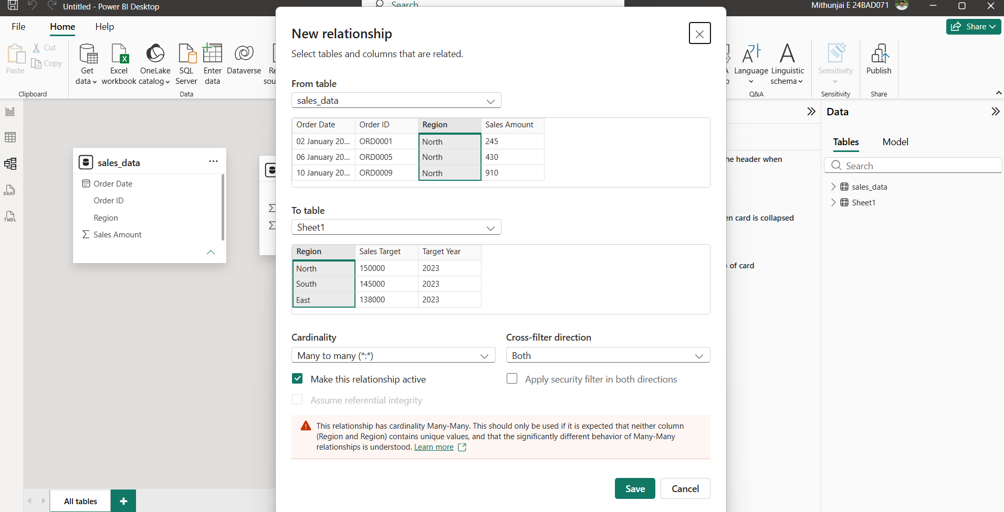

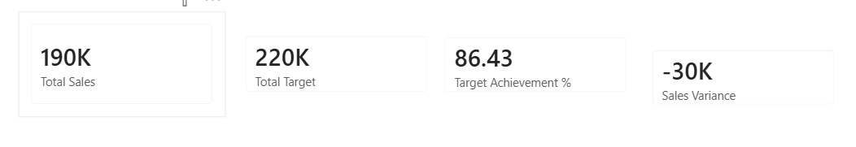

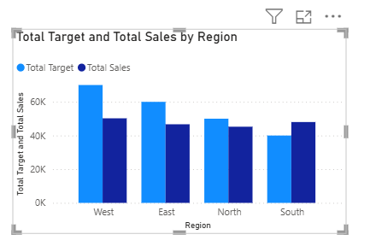

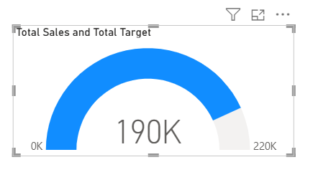

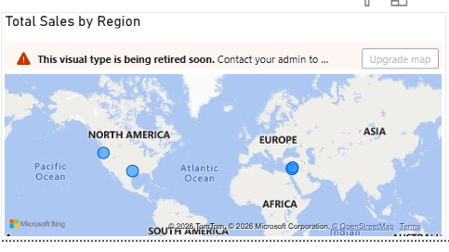

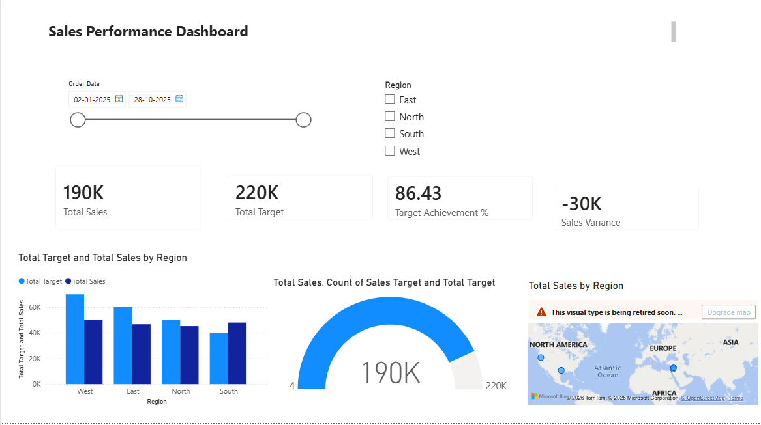

Tableau:
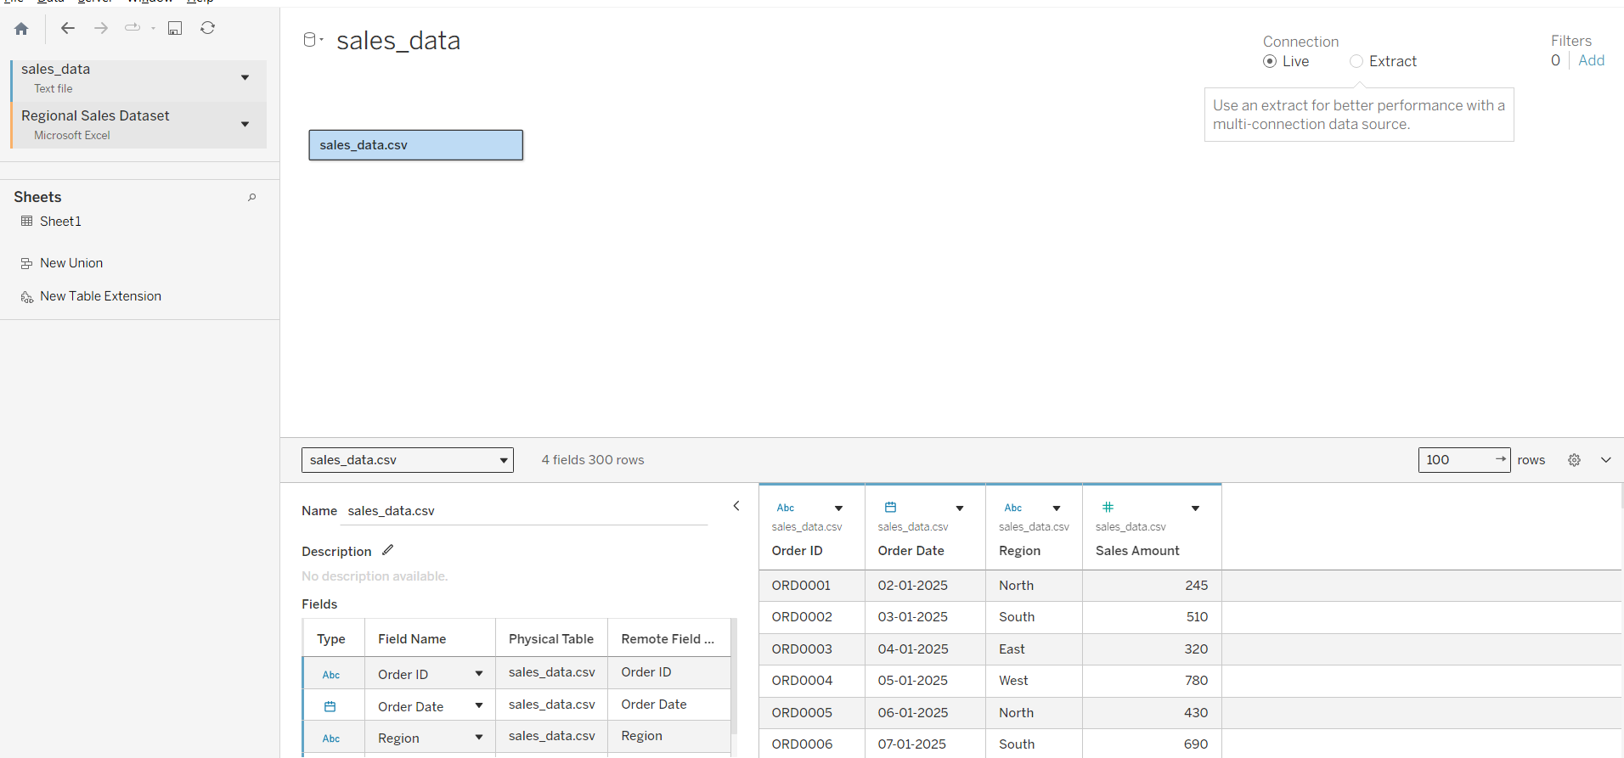

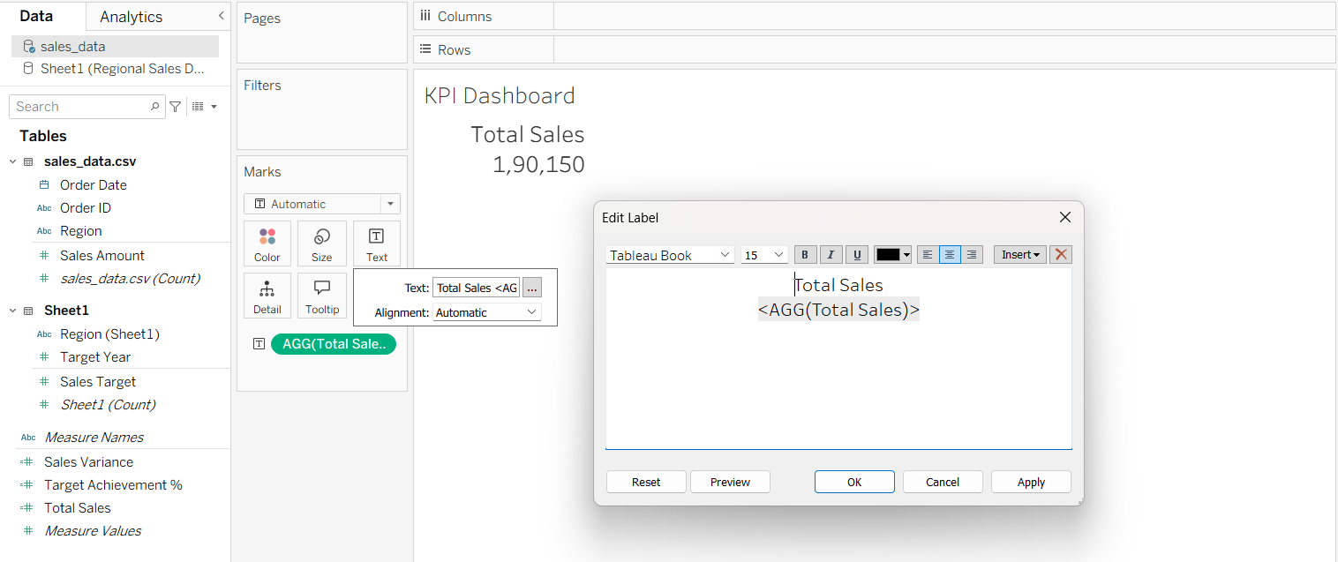

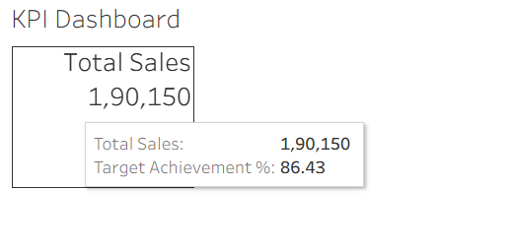

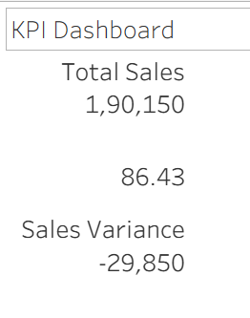

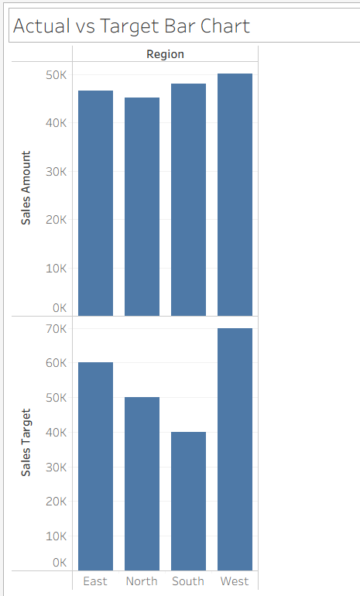

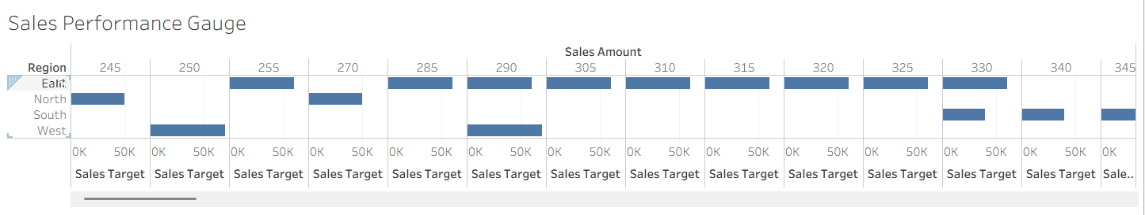

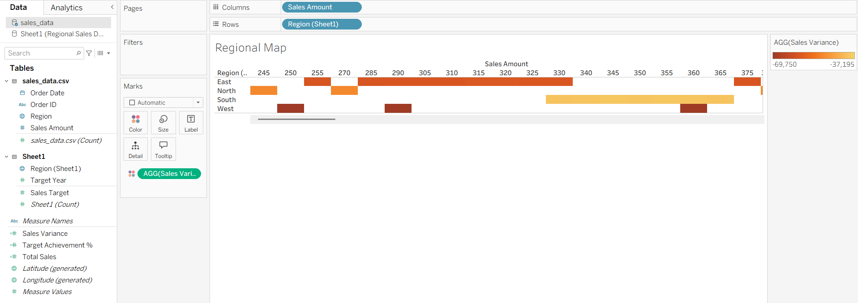

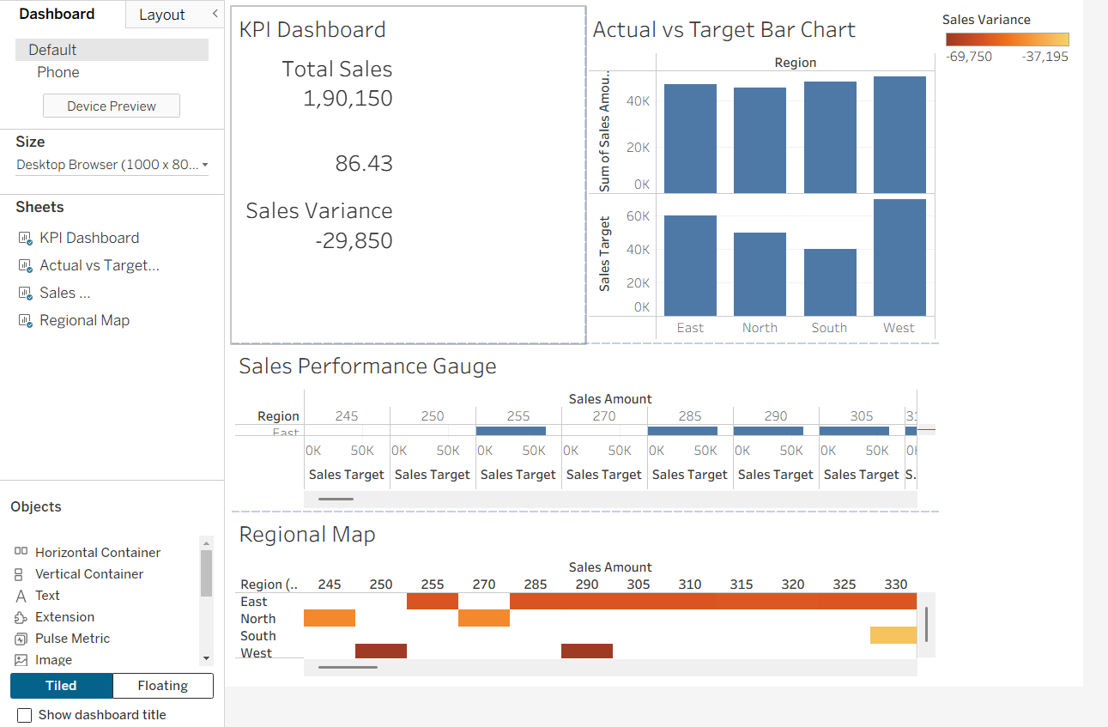

POST-LAB QUESTIONS (PROVIDE BRIEF ANSWERS TO THE FOLLOWING QUESTIONS)
- How did integrating the sales targets data provide a more complete analytical picture than using the sales data alone?

- Describe the type of join or relationship you used to combine the two datasets and explain why it was the appropriate choice.

- What challenges, if any, did you face regarding data granularity or mismatched keys (e.g., different region names) between the two sources?

- How can creating variance calculations (e.g., Sales vs. Target) help a business manager make better decisions?

- What other data source (e.g., marketing campaign data, customer demographics) could you integrate to further enrich this analysis, and what new insights might it provide?

RESULT:

The retail sales and regional targets datasets were successfully connected, cleaned, and integrated in both Tableau and Power BI. By creating relationships between the sources, a unified data model was built. The resulting comprehensive dashboard visualized sales performance against set targets, enabling variance analysis and providing deeper, context-rich insights into regional performance that were not possible with a single data source.

ASSESSMENT

Description |  | Max Marks | Marks Awarded
Pre Lab Exercise |  | 5
In Lab Exercise |  | 10
Post Lab Exercise |  | 5
Viva |  | 10
 | Total | 30
 | Faculty Signature

